**Project Name: Pawsome- A perfect place for Dog Adoption and Care**

**Project Member:**

**Rushikesh Jadhav 220343120039**

**Rahul Zunjar 220343120088**

**Prachi Sonone 220343120105**

**Shrinivas Vader 220343120111**

**Abstract:**

Pawsome- A perfect place for adoption and care of dog is a web-based application wherein welfare of dogs is taken care of. Admin have full control over the application. If someone wants to adopt a dog it is a perfect place. This application allows the user to adopt a dog.

This project deals with developing a platform for dog adoption. It provides to user adoption and care facility. If user wants to keep his/her dog for some days to any safe place then care facility is useful for them. Care facility provides dog hostels and doctors details they can access this through community. Doctor’s appointment facility is also available there.

The system is implemented using a 3-tier approach, with a backend database, a middle tier of Spring boot and Express JS, React JS as the front end tier. In order to develop platform for adoption and care for dogs, a number of Technologies must be studied and understood. These include multi-tiered architecture, server and client side scripting techniques, implementation technologies such as Spring boot, programming language (such as Core Java, Advance Java), relational databases (such as MySQL).

This project with the objective to develop a basic website so that anyone can easily adopt and care for dogs.

**Implementation Technologies:**

**1.1 Features of Spring Framework:**

1. **Spring Boot:**

Spring Boot is an open source Java-based framework used to create a micro Service. It is developed by Pivotal Team and is used to build stand-alone and production ready spring applications.

**1.1 Features of Spring Framework:**

## 1. Web Development

It is well suited Spring module for web application development. We can easily create a self-contained HTTP server using embedded Tomcat, Jetty or Undertow. We can use the spring-boot- starter-web module to start and running application quickly.

**2.Spring Application**

It is a class which provides the convenient way to bootstrap a spring application which can be started from main method. You can call start your application just by calling a static run() method.

**3.Admin Support**

Spring Boot provides the facility to enable admin related features for the application. It is used to access and manage application remotely. We can enable it by simply using spring.application.admin.enabled property.

**4.Externalized Configuration**

Spring Boot allows us to externalize our configuration so that we can work with the same application in different environments. Application use YAML files to externalize configuration.

**5.Security**

Spring Boot applications are spring bases web applications. So, it is secure by default with basic authentication on all HTTP endpoints. A rich set of Endpoints are available for develop a secure Spring Boot application.

**2.1** **MySQL**

MySQL, the most popular Open Source SQL database management system, is developed, distributed, and supported by Oracle Corporation.

**Features of MySQL:**

* **MySQL is a database management system.**

A database is a structured collection of data. It may be anything from a simple shopping list to a picture gallery or the vast amounts of information in a corporate network. To add, access, and process data stored in a computer database, you need a database management system such as MySQL Server. Since computers are very good at handling large amounts of data, database management systems play a central role in computing, as standalone utilities, or as parts of other applications.

* **MySQL databases are relational.**

A relational database stores data in separate tables rather than putting all the data in one big storeroom. The database structures are organized into physical files optimized for speed. The logical model, with objects such as databases, tables, views, rows, and columns, offers a flexible programming environment.

* **MySQL software is Open Source.**

Open Source means that it is possible for anyone to use and modify the software. Anybody can download the MySQL software from the Internet and use it without paying anything.

* **The MySQL Database Server is very fast, reliable, scalable, and easy to use.**

MySQL Server was originally developed to handle large databases much faster than existing solutions and has been successfully used in highly demanding production environments for several years. Although under constant development, MySQL Server today offers a rich and useful set of functions. Its connectivity, speed, and security make MySQL Server highly suited for accessing databases on the Internet.

* **MySQL Server works in client/server or embedded systems.**

The MySQL Database Software is a client/server system that consists of a multithreaded SQL server that supports different back ends, several different client programs and libraries, administrative tools, and a wide range of application programming interfaces (APIs).

**3.React**

The React. js framework is an open-source JavaScript framework and library developed by Facebook. It's used for building interactive user interfaces and web applications quickly and efficiently with significantly less code than you would with vanilla JavaScript.

1. **Hardware and Software Requirements (Minimum):**

**Hardware:**

1. Intel i3 processor 3rd generation or later

2. 2 GB ddr3 ram.

3. Windows 7 Home edition or later.

4. 200 GB Sata HDD Space

5. Data Connection 200 kbps

**Software:**

1. Spring Tool Suits(STS)
2. MySQL 5.7 with Workbench 8.0
3. Google Chrome version 79.0
4. Maven Dependencies
5. **ER Diagram:**

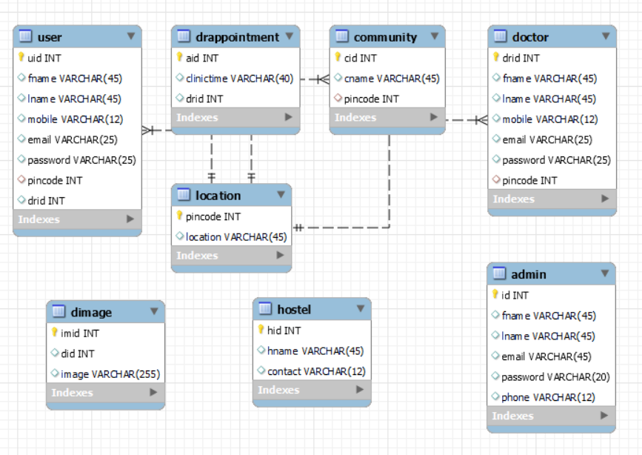

Figure 1: ER Diagram

1. **Table Structures:**
2. **Table name: Admin**

**Column name Type NULL Key Extra**

id int NO PRI auto_increment fname varchar(45) YES

lname varchar(45) YES

email varchar(45) YES

password varchar(20) YES

phone varchar(12) YES

1. **Table name: Community**

**Column name Type Null Key Extra**

cid int NO PRI auto_increment

cname varchar(45) YES

pincode int YES MUL

1. **Table name: User**

**Column name Type Null Key Extra**

uid int NO PRI auto_increment

fname varchar(45) YES

lname varchar(45) YES

mobile varchar(12) YES

email varchar(25) YES

password varchar(25) YES

pincode int YES MUL

drid int YES MUL

1. **Table name: Doctor**

**Column name Type Null Key Extra**

drid int NO PRI auto_increment

fname varchar(45) YES

lname varchar(45) YES

mobile varchar(12) YES

email varchar(25) YES

password varchar(25) YES

pincode int YES MUL

1. **Table name: Dog**

**Column name Type Null Key Extra**

did int NO PRI auto_increment

dname varchar(45) YES

dage varchar(45) YES

dbreed varchar(25) YES

1. **Table name: Location**

**Column name Type Null Key Extra**

pincode int NO PRI auto_increment

location varchar(45) YES

1. **UML Diagrams:**

Admin

Log Out

Add / Remove Hostel

Add / Remove Doctor

Add / Remove Community

Add / Remove User

Add / Remove Dog

Home

Dash-Board

Admin

Figure 2: Admin

UML Diagram: User

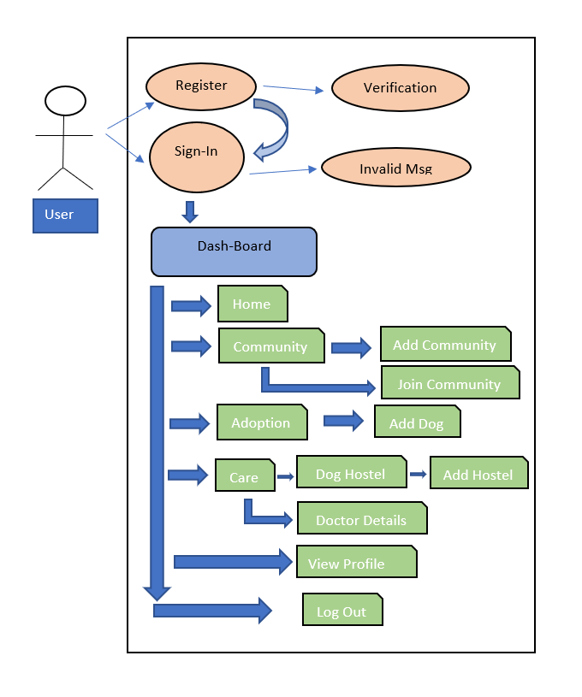

UML Diagram: Doctor

View Appointment

Home

Dash-Board

Doctor

Your Patients

View Profile

Log Out

**End to End Flow of Application**

**User**:

1. User will login to portal or will have register if he is not a register user.
2. After registration user will login and Dashboard page will be display to him which will display Home, Community, Adoption, Care, View Profile and Log out.
3. In Community page will be display Existing Community Details to user. With the help of that user can Join Community and Create Community.
4. In Adoption page will be display List of Adoption Dogs and user can also add dog in adoption list.
5. In Care page will be display Hostel Details and Doctor Details.(Tips & Trick page)
6. After Logout it will redirect to home page.

**Admin**:

1. Admin will login to the portal or will have to register if he is not a registered user.
2. After register admin will login dashboard page will be display to him which will display Add/Remove User, Add/Remove Dog, Add/Remove Doctor, Add/Remove Hostel, Add/Remove Community.
3. After ‘Log Out’ it will open home page.

**Doctor:**

1. Doctor will login to the portal or will have to register if he is not a registered.
2. After registration doctor will login and dashboard page will be displayed to him which will display Appointment Details, Patients list, View Profile and log out.
3. After ‘Log Out ’ it will open home page.
4. **Future Scope of Project:**

* Donation option for some financial help to NGO
* Volunteer module to participate volunteers to help the stray animals
* Use for homeless animals

**Thank You!**